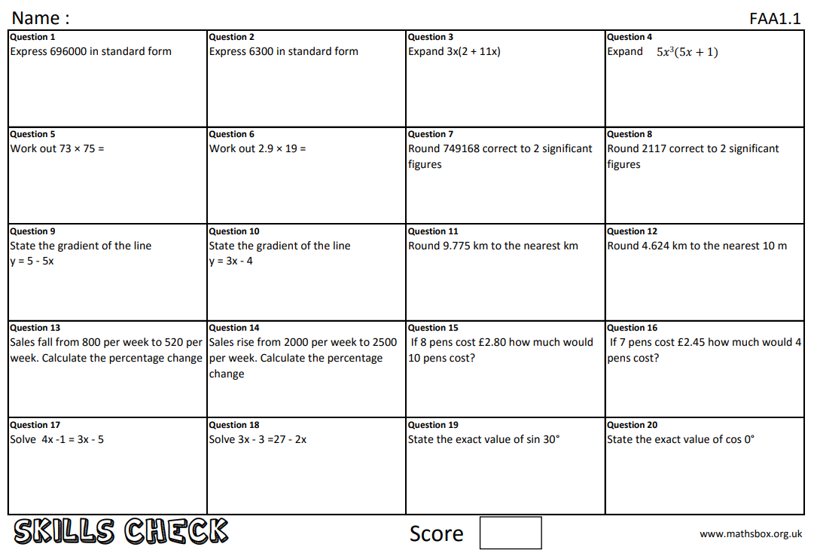
Year 10 maths work 6/12/19

