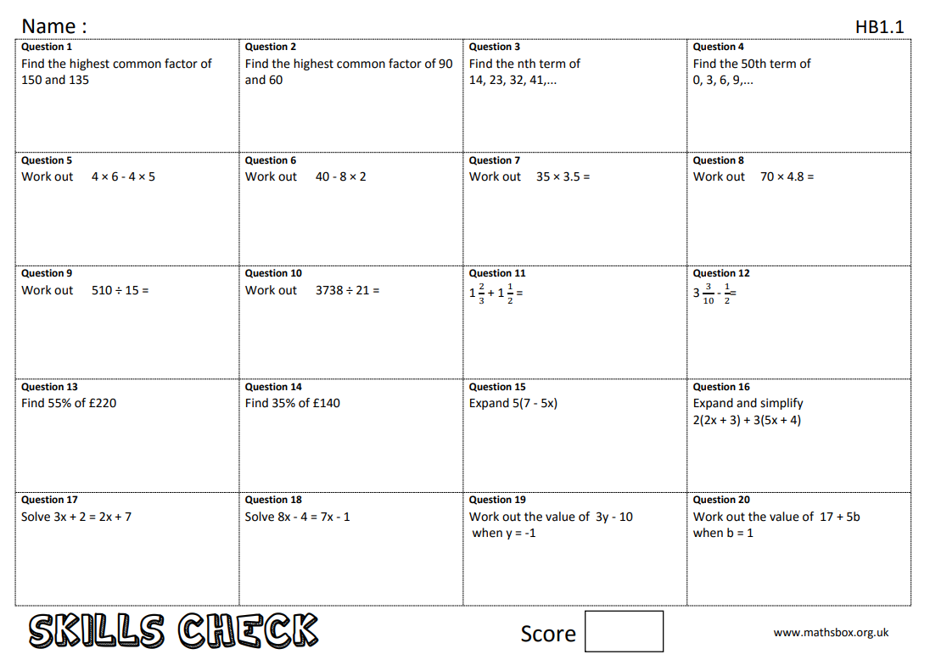
Year 11 Foundation maths work 6/12/19

