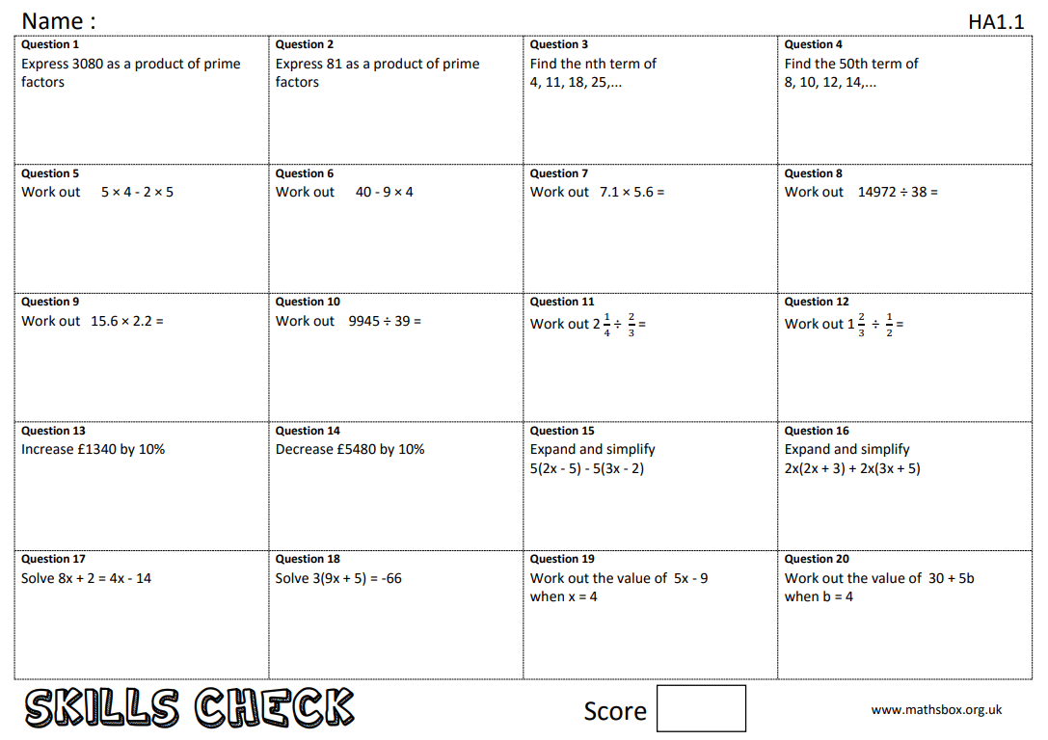
Year 11 Higher maths work 6/12/19

