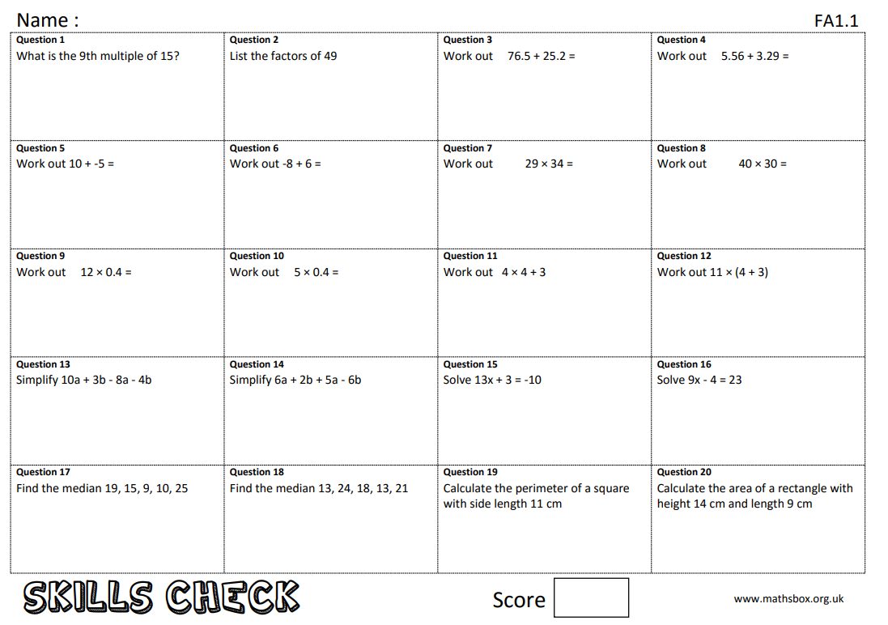
Year 9 maths work 6/12/19

